Powering Algorithm
1. Problem Statement
Given a base number x and a power n, the task is to find the value of x raised to the power n. A simple way is to multiply x by itself n times, but this becomes slow when n is very large, so a faster method is needed.
2. Approach Used
The fast power method works by repeatedly squaring the base and reducing the power by half at every step. If the current power is odd, the result is multiplied by the current base before squaring it. This way the answer is found in very few steps instead of n steps.
3. C Program
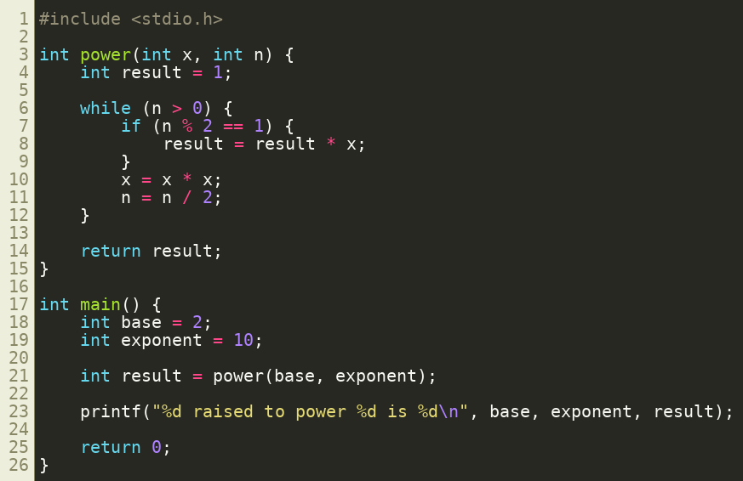
4. Output

5. Complexity
This method takes O(log n) time since the power is cut in half at every step

